BLOWER WHEELS (DOUBLE ENTRY)

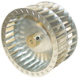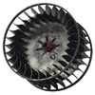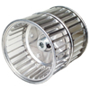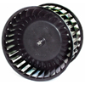
NEKY1117001 NEKY1175003 NEKY1199001 NEKY1199006
FLEETRITE ZGG11621 BLUEBIRD 08307365 FLEETRITE ZGG1628 FREIGHT/ALLIANCE 302112
I.C. CORP 427484008 INTERNATIONAL ZGG702021 FREIGHT/ALLIANCE INTERNATIONAL 2507231C1

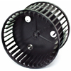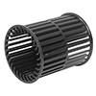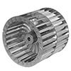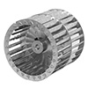
NEKY1199007 NEKY1199009 NEKY1199028 NEKY1199029
BLUEBIRD 00033722 FLEETRITE ZGG11029 BLUEBIRD 08304636 BLUEBIRD 08304602
FREIGHT/ALLIANCE 302042/302222 FREIGHT/ALLIANCE 302032 I.C. CORP 450037019 I.C. CORP 450037008
FREIGHT OEM ABP N83 302042 FREIGHT OEM KYS260680 INTERNATIONAL 450037008
INTERNATIONAL 1691728C1

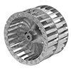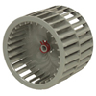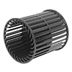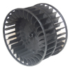
NEKY1199030 NEKY1199035 NEKY1199036 NEKY1199037
INTERNATIONAL 1655565C1 FREIGHT/ALLIANCE 302222 INTERNATIONAL ZGG702017 INTERNATIONAL ZGG702017
FREIGHT/OEM KYS 360480
INTERNATIONAL 1691727C1

PHONE 1-866-934-7665 FOR PRICE AND AVAILABILITY
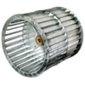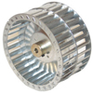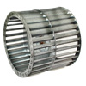
NEKY1199037 NEKY1199038 NEKY1199042 NEKY1199044
INTERNATIONAL ZGG702017 FREIGHT/OEM BSM 510014 BLUEBIRD 04316543 FREIGHT/ALLIANCE 302132
INTERNATIONAL ZGG702012 FLEETRITE ZGG 11620 FREIGHT/OEM BSM 566300
FREIGHT/OEM KYS 260570 THOMAS BUILT BUS 2602-6374

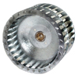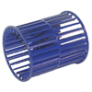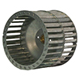
NEKY1199045 NEKY1199047 NEKY1199049
FREIGHT/ALLIANCE 302142 BLUEBIRD 00066114 FREIGHT/ALLIANCE 302122
FREIGHT/OEM BSM 571040 INTERNATIONAL ZGG702018 FREIGHT/OEM BSM 538700
THOMAS BUILT BUS 8566-0238 THOMAS BUILT BUS 2607-0370

PHONE 1-866-934-7665 FOR PRICE AND AVAILABILITY

