BLOWER MOTORS AND ASSEMBLIES

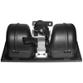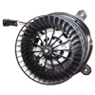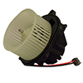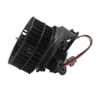
NEKY101201 NEKY1013008 NEKY1013012 NEKY1013013
FREIGHTLINER/ALLIANCE 301147 FASCO 2898-091-027 INTERNATIONAL 3599581C2 FLEETRITE FLTBM3674285
FREIGHT/OEM 2809-820-016 FLEETRITE FLTBM3542611 INTERNATIONAL 3674285C1
INTERNATIONAL ZGG7010126 FREIGHT/ALLIANCE 301304
INTERNATIONAL 3542611C2

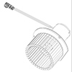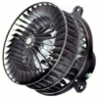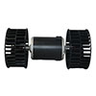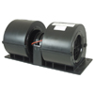
NEKY1017007 NEKY1018002 NEKY1018006 NEKY1075018
INTERNATIONAL ZGG701123 FREIGHT/ALLIANCE 3017971 FREIGHT/ALLIANCE 301274 FREIGHT/OEM BSM B411407
FREIGHT/OEM RDH RD5 10385 0 INTERNATIONAL ZGG701083
INTERNATIONAL ZGG701016

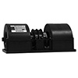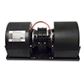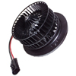
NEKY1075020 NEKY1075025 NEKY1075044 NEKY1099063
FASCO 2898-092-017 FASCO 2898-092-007 INTERNATIONAL ZGG701113 FASCO 2809-841-029
FREIGHT/OEM KYS411343 FREIGHT/OEM KYS411271 FLEETRITE ZGG19230
INTERNATIONAL 452046010 INTERNATIONAL 411271 FRT/ALLIANCE 301307/301018
FREIGHT/OEM BSM 868790

PHONE 1-866-934-7665 FOR PRICE AND AVAILABILITY
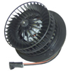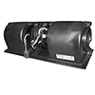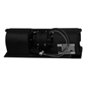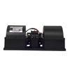
NEKY1099064 NEKY1099077 NEKY1099090 NEKY1099095
FASCO 2898-091-018 BLUEBIRD 00035883 FASCO 2898-072-021 FASCO 2898-092-016
FREIGHT/ALLIANCE 301891 FASCO 2890-072-020 FREIGHT/OEM BSM 1000046149 INTERNATIONAL 437122023
INTERNATIONAL ZGG701025 FREIGHT/OEM BSM10000046148 INTERNATIONAL ZGG701108
INTERNATIONAL 2598644C1

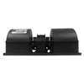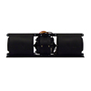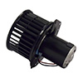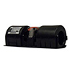
NEKY1099097 NEKY1099098 NEKY1099116 NEKY1099119
BLUEBIRD 0009019 IC CORP 2217914C1 FREIGHT/OEM BSM 869158 BLUEBIRD 10016426
FREIGHT/OEM BSM519703 INTERNATIONAL 2217914C1 INTERNATIONAL 2507242C1 FRT/OEM BSM1000033591
INTERNATIONAL 2607897C91 INTERNATIOANL ZGG701122
THOMAS BSM 1000033591

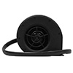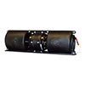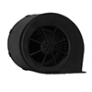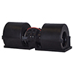
NEKY1099120 NEKY1099121 NEKY1099130 NEKY1099131
INTERNATIONAL 2594604C92 INTERNATIONAL 2230256C91 INTERNATIONAL 2595282C91 FASCO 2898-192-002N

PHONE 1-866-934-7665 FOR PRICE AND AVAILABILITY

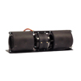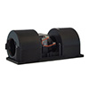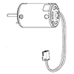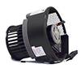
NEKY1099132 NEKY1099134 NEKY1099146 NEKY1099157
FASCO 2898-072-004 FREIGHTLINER/OEM BSM E525095 FREIGHTLINER/OEM 1000694282 FREIGHT/OEM A22-75338-000

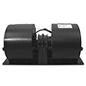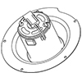
NEKY1099161 (OLD # 1099084) NEKY4099138
BLUEBIRD 08303182 INTERNATIONAL ZGG739151
BLUEBIRD 00010597
FREIGHT/OEM BSM 1000146165
IC CORP 452046009
INTERNATIONAL 2606226C91

PHONE 1-866-934-7665 FOR PRICE AND AVAILABILITY

